**Lab 05**

**21k-3881**

**Task 01**

import java.util.*;  
public class ta1{  
 public static void main(String[] args){  
 Scanner t=new Scanner(System.*in*);  
 try{  
 System.*out*.println("input letter = ");  
 String u;  
 u=t.nextLine();  
 if(*s_letter*(u)){  
 throw new Exception("lower case letter not allowed!!!"); }  
 if(u.contains("A")){  
 throw new Exception("A not allowed!!!"); }  
 if(u.contains("B")){  
 throw new Exception("B not allowed!!!"); }  
 System.*out*.println(u+" is a capital letter!!!"); }  
 catch(Exception ae){  
 System.*out*.println("Caught an exception: " + ae.getMessage()); }  
 }  
 private static boolean s_letter(String u){  
 for(char ch : u.toCharArray()){  
 if (Character.*isLowerCase*(ch)){  
 return true; } }  
 return false;}  
}

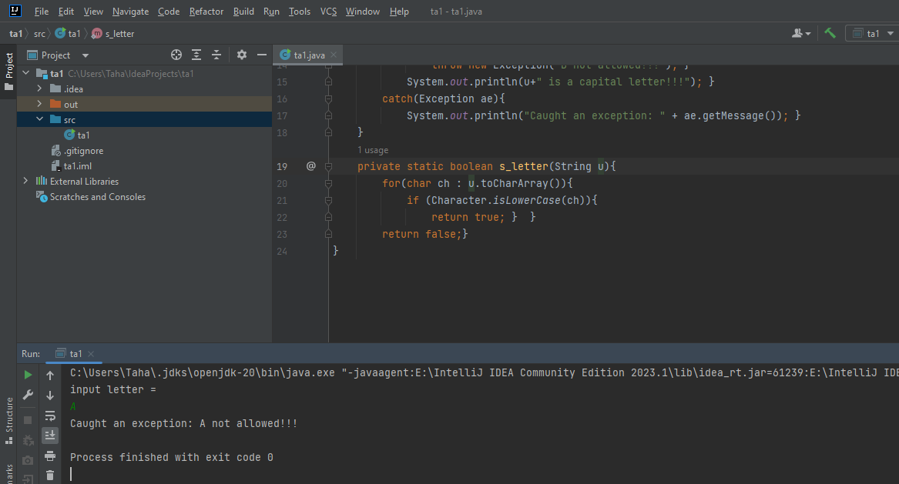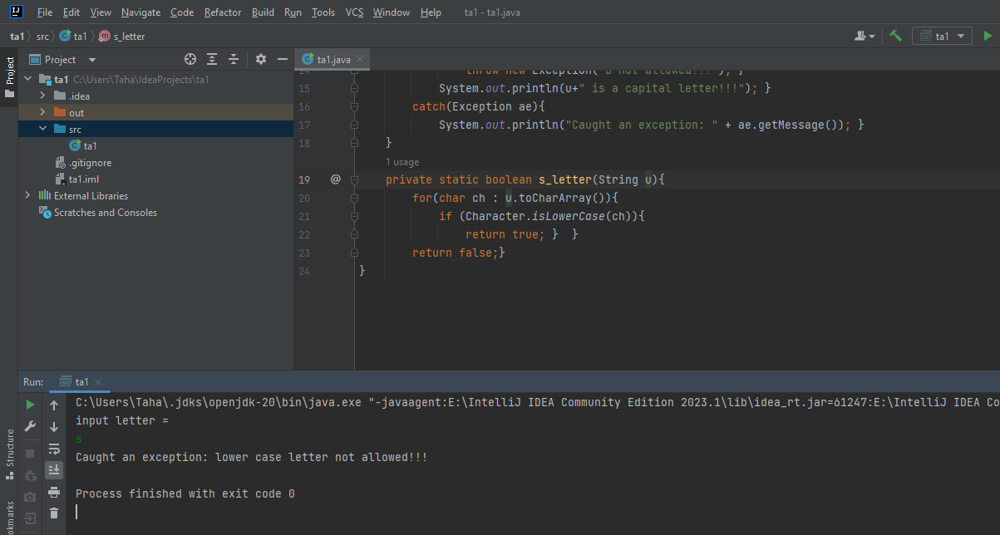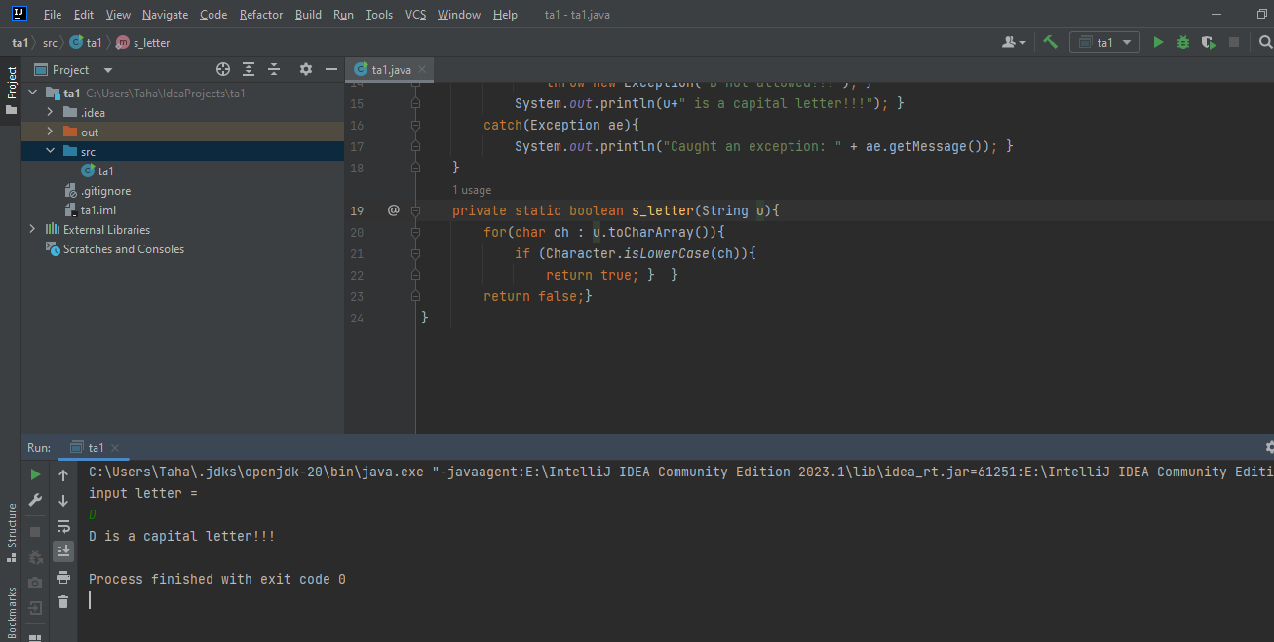

**Task 02**

import java.util.*;  
public class ta2{  
 public static void main(String[] args) {  
 try{  
 Scanner t=new Scanner(System.*in*);  
 System.*out*.println("input letter = ");  
 String u;  
 u=t.nextLine();  
 if(u.contains("A")){  
 throw new Exception("A not allowed!!!"); }  
 if(u.contains("B")){  
 throw new Exception("B not allowed!!!"); }  
 if(!u.matches("^[A-Z]*$")){  
 throw new invalid_character("You put invalid character!!!"); }  
 System.*out*.println("Input is valid: "+u); }  
 catch (Exception ae){  
 if(ae instanceof invalid_character){  
 System.*out*.println("Some error Occurred!!!"); }  
 else if (ae.getMessage().equals("A")){  
 System.*out*.println("A"); }  
 else if (ae.getMessage().equals("B")){  
 System.*out*.println("B"); }  
 else{  
 System.*out*.println("Some error occurred!!!"); } }  
 } }  
class invalid_character extends Exception{  
 public invalid_character(String m){  
  
 super(m); } }

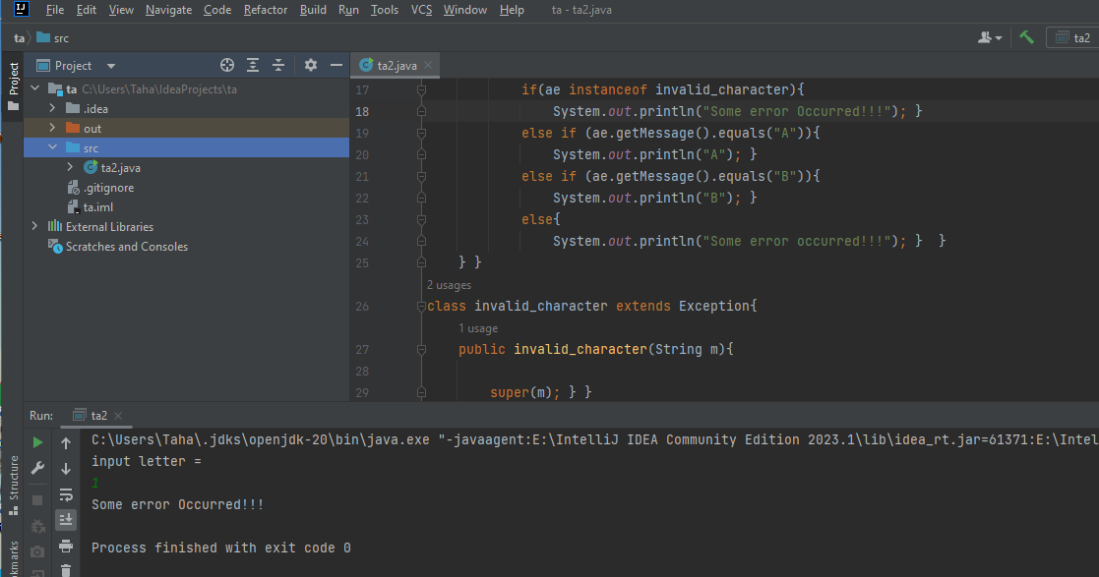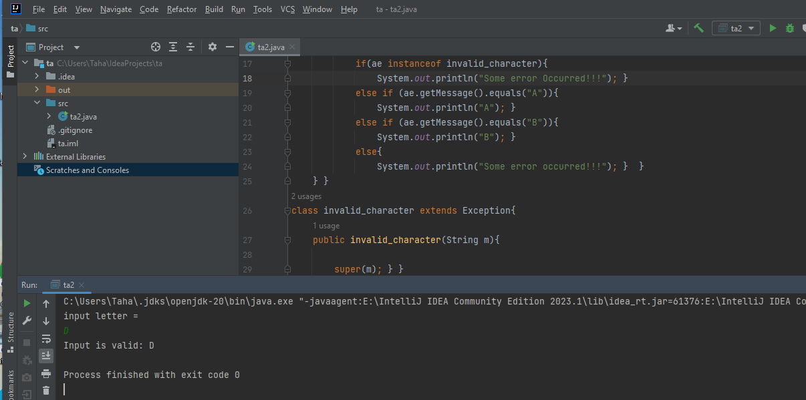

**Task 03**

import java.io.*;  
public class ta3{  
 public static void main(String[] args) throws FileNotFoundException{  
 String u;  
 u="21k-3881";  
 int le=u.length();  
 System.*out*.println("String length = "+le);  
 String fn="taha.txt";  
 try(FileWriter w=new FileWriter(fn)){  
 w.write(u);  
 System.*out*.println("Successfully write in this file!!!"); }  
 catch(IOException ae) {  
 System.*out*.println("Exception occurred = "+ae.getMessage()); }  
 try(FileReader r=new FileReader(fn)){  
 StringBuilder b=new StringBuilder();  
 int l;  
 while((l=r.read())!=-1){  
 b.append((char) l); }  
 String m=b.toString();  
 System.*out*.println("Received!!!\n"+m); }  
 catch (IOException ae) {  
 System.*out*.println("Excseption occurred = "+ae.getMessage());  
 }  
 }  
}

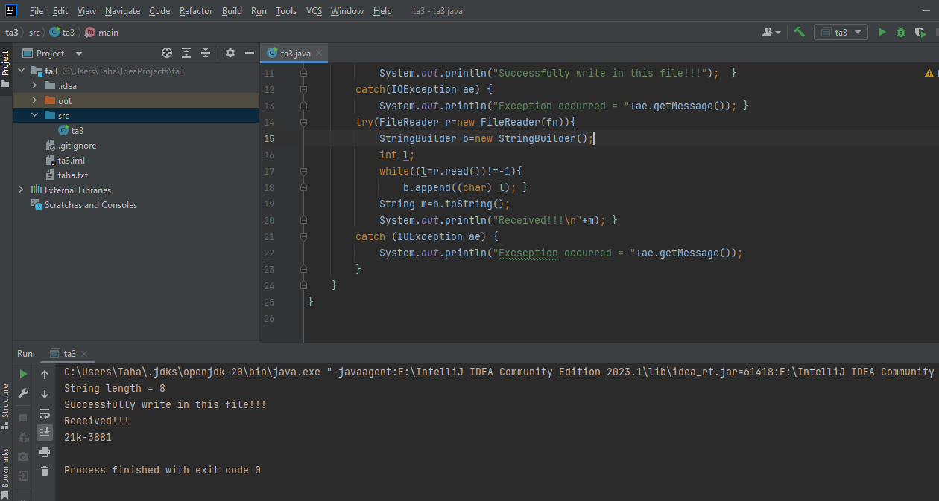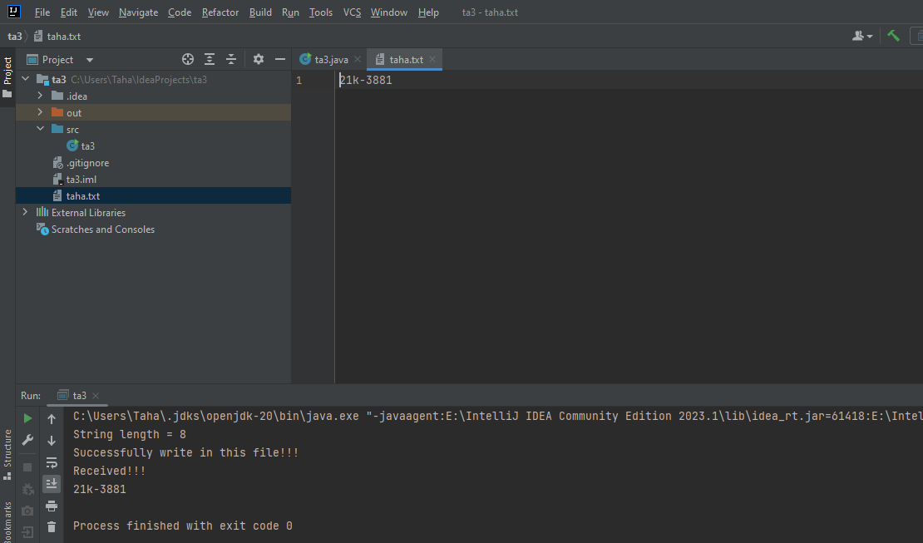

**Task 04**

public class ta4{  
 public static <T extends Number> double div(T d1,T d2){  
 if(d2.doubleValue()==0){  
 throw new ArithmeticException("Division by zero"); }  
 return d1.doubleValue()/d2.doubleValue(); }  
 public static <T extends Number> double sub(T d1,T d2){  
 return d1.doubleValue()-d2.doubleValue(); }  
 public static <T extends Number> double add(T d1,T d2){  
 return d1.doubleValue()+d2.doubleValue(); }  
 public static <T extends Number> double mul(T d1,T d2){  
 return d1.doubleValue()*d2.doubleValue(); }  
 public static void main(String[] args) {  
 int x=3,y=4;  
 double p=35.0,q=16.0;  
 System.*out*.print("Division = "+*div*(p,y)+" ");  
 System.*out*.println("Subtraction = "+*sub*(p,q));  
 System.*out*.print("Addition = "+*add*(x,y)+" ");  
 System.*out*.println("Multiplication = "+*mul*(x,q));  
 } }

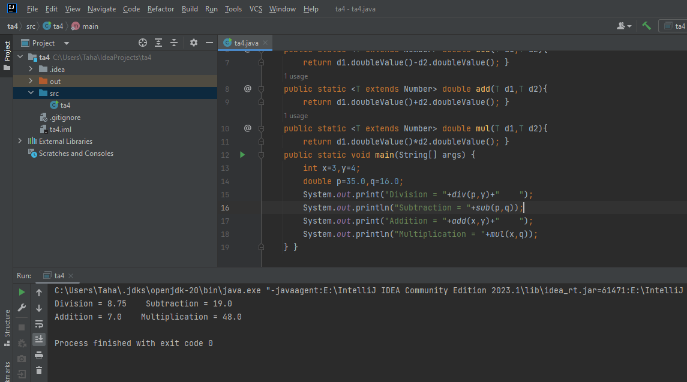

**Task 05**

**BY HASHSET**

import java.util.ArrayList;  
import java.util.HashSet;  
import java.util.Iterator;  
public class ta5{  
 public static void main(String[] args) {  
 HashSet<Object>hs=new HashSet<>();  
 hs.add("taha");  
 hs.add("jawaid");  
 hs.add(67);  
 hs.add(75);  
 hs.add(88);  
 Iterator<Object>it=hs.iterator();  
 while(it.hasNext()){  
 Object obj=it.next();  
 System.*out*.println(obj);  
 }  
 } }

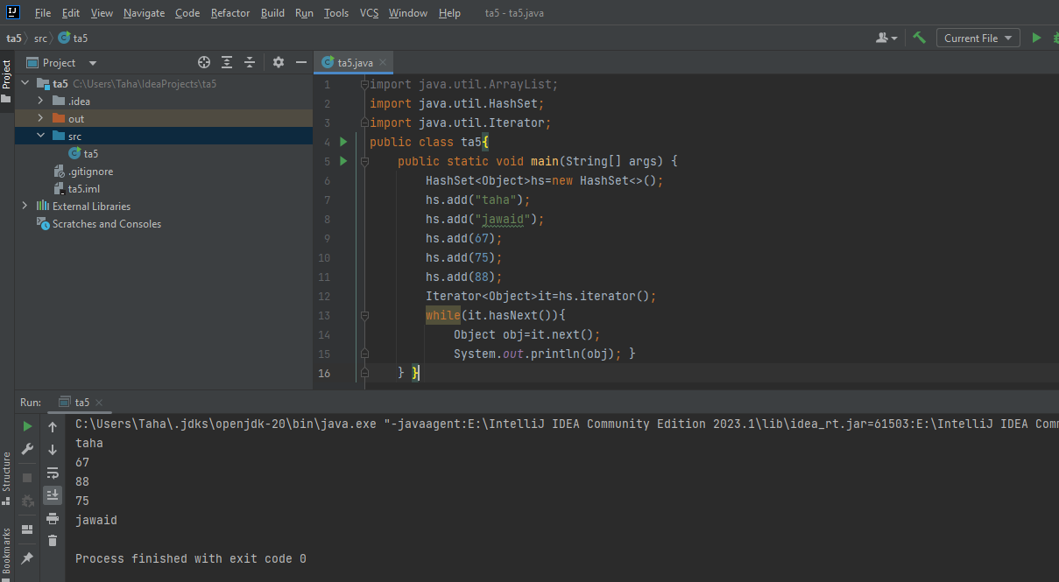

**BY ARRAYLIST**

import java.util.ArrayList;  
import java.util.HashSet;  
import java.util.Iterator;  
public class ta5_arr{  
 public static void main(String[] args) {  
 ArrayList<Object>ar=new ArrayList<>();  
 ar.add("taha");  
 ar.add("jawaid");  
 ar.add(67);  
 ar.add(75);  
 ar.add(88);  
 Iterator<Object>it=ar.iterator();  
 while(it.hasNext()){  
 Object obj=it.next();  
 System.*out*.println(obj); }  
 } }

